**Round Top Church Christian Fellowship**

*Look unto the Resurrection and Be Ye Saved*

***Acts 23:12-35, Isaiah 45:22***

*Pastor ~ Matthew Diehl*

April 18th In the Year of Our Lord

(Anno Domini A.D.) 2021

Pentecost (Shavuot) May 16, 2021

(Unless otherwise noted, NAS is quoted.)

We continue our review of Paul’s arrest and trials in Jerusalem. Paul’s arrest and imprisonment provides many opportunities to witness the Gospel which includes the Resurrection of Jesus. Paul gives this resurrection detail every chance he gets. We see inside the Jewish groups that there are fanatics who will not rest until they have killed Paul. However, Paul continues to rely upon the Roman law and Roman military leaders to protect his rights as a Roman citizen. Again, government here is being used for good, which God intended. We continue to see that the Roman law protected Paul. It was the crazed mob of the Jews that did not want to observe the Roman law nor their own.

12 When it was day, the Jews formed a conspiracy and bound themselves under an oath, saying that they would neither eat nor drink until they had killed Paul.

13 There were more than forty who formed this plot.

14 They came to the chief priests and the elders and said, "We have bound ourselves under a solemn oath to taste nothing until we have killed Paul.

15 "Now therefore, you and the Council notify the commander to bring him down to you, as though you were going to determine his case by a more thorough investigation; and we for our part are ready to slay him before he comes near the place."

16 But the son of Paul's sister heard of their ambush, and he came and entered the barracks and told Paul.

17 Paul called one of the centurions to him and said, "Lead this young man to the commander, (**χιλίαρχος** *chiliarchos)* for he has something to report to him."

This is the same “Roman Commander” who acted in Acts 21.

31 While they were seeking to kill him, a report came up to the commander of the *Roman* cohort that all Jerusalem was in confusion.

32 At once he took along *some* soldiers and centurions and ran down to them; and when they saw the commander and the soldiers, they stopped beating Paul.

33 Then the commander came up and took hold of him, and ordered him to be bound with two chains; and he *began* asking who he was and what he had done.

**Commander**

**Strong’s <5506>** **χιλίαρχος** *chiliarchos*

**Meaning:** a chiliarch, a commander of a thousand

**Origin:** from *5507* and **αρχος** *archos (leader)*

**Usage:** commander (18), commanders (3), military commanders (1).

**Notes:** *chiliarch*, in command of one thousand troops or *battalion (*Act 10:1).

18 So he took him and led him to the commander and said, "Paul the prisoner called me to him and asked me to lead this young man to you since he has something to tell you."

19 The commander took him by the hand and stepping aside, began to inquire of him privately, "What is it that you have to report to me?"

20 And he said, "The Jews have agreed to ask you to bring Paul down tomorrow to the Council, as though they were going to inquire somewhat more thoroughly about him.

21 "So do not listen to them, for more than forty of them are lying in wait for him who have bound themselves under a curse not to eat or drink until they slay him; and now they are ready and waiting for the promise from you."

22 So the commander let the young man go, instructing him, "Tell no one that you have notified me of these things."

23 And he called to him two of the centurions and said, "Get two hundred soldiers ready by the third hour of the night to proceed to **Caesarea**, with seventy horsemen and two hundred spearmen."

24 They were also to provide mounts to put Paul on and bring him safely to Felix the governor.

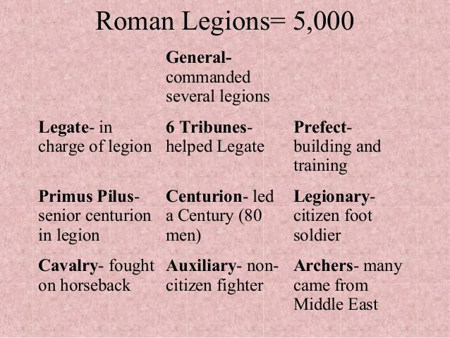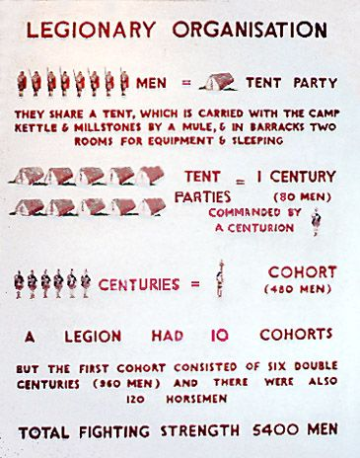

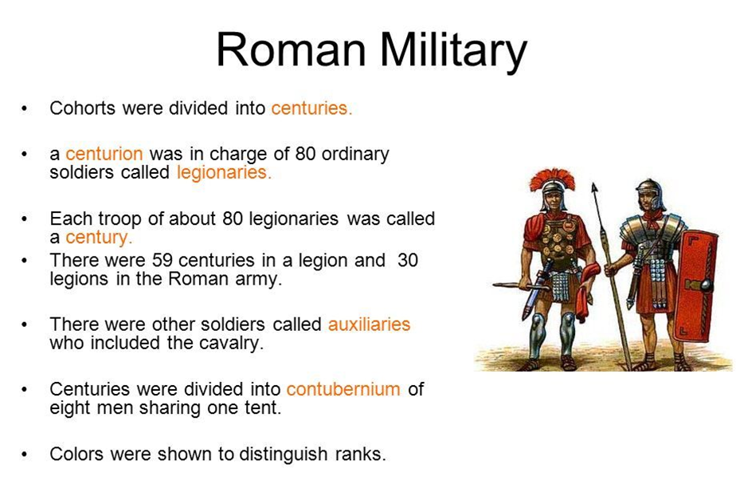

<https://www.pinterest.co.uk/pin/175007135503091888/>

**Claudius Lysias Letter**

25 And he wrote a letter having this form:

26 "Claudius Lysias, to the most excellent governor Felix, greetings.

27 "When this man was arrested by the Jews and was about to be slain by them, I came up to them with the troops and rescued him, having learned that he was a Roman.

28 "And wanting to ascertain the charge for which they were accusing him, I brought him down to their Council;

29 and I found him to be accused over questions about their Law, but under no accusation deserving death or imprisonment.

30 "When I was informed that there would be a plot against the man, I sent him to you at once, also instructing his accusers to bring charges against him before you."

We note here that the commander did not cite Paul’s claim about the “resurrection of the dead” as a reason he was being detained. The Commander’s view of the Jewish allegations is seen as overall complaint dealing with their own internal system.

With Paul’s claim of being a Roman citizen, the Commander was pressed under the rule of Roman law to assure Paul’s Roman rights were upheld. We see this in the fact that the Commander assigned a large number of soldiers to take Paul to Caesarea.

23 And he called to him two of the centurions and said, "Get two hundred soldiers ready by the third hour of the night to proceed to **Caesarea**, with seventy horsemen and two hundred spearmen."

This could be as many as 470 soldiers in all (200 + 70 + 200). However, this order could be counted with the horsemen and spearmen as some part of the base 200 soldiers. If that is true, then the number would be no less than 270 soldiers. This is still a formidable fighting force. It also highlights that the Jews were seen by the Romans as people that could gather a sizable number of men together to oppose them.

31 So the soldiers, in accordance with their orders, took Paul and brought him by night to **Antipatris**.

32 But the next day, leaving the horsemen to go on with him, they returned to the barracks.

33 When these had come to **Caesarea** and delivered the letter to the governor, they also presented Paul to him.

34 When he had read it, he asked from what province he was, and when he learned that he was from **Cilicia**,

35 he said, "I will give you a hearing after your accusers arrive also," giving orders for him to be kept in **Herod's Praetorium**.

We see Governor Felix receiving Paul personally. The fact that Paul was accompanied by such a large number of soldiers told Felix of the importance of Paul’s arrest and meaning to the Jewish leaders.

**Resurrection – The Foundational Message**

It is of note that the foundational message of Christianity is rooted in the Resurrection. This is the message upon which Paul focused that divided the Pharisees and the Sadducees. Today, this is still the message that divides people. Last week, we looked at proofs of the Resurrection. This week, we will focus on the **reasons** for the Resurrection. By this question, we highlight the apparent reasons why God chose the Cross as the event from which to be resurrected. The Cross is what God said He would do (Psalm 22, Isaiah 53).

Therefore, Old Testament prophecy was fulfilled.

**Zechariah 13:7** "Awake, O sword, against My Shepherd, And against the man, My Associate," Declares the LORD of hosts. "Strike the Shepherd that the sheep may be scattered; And I will turn My hand against the little ones.

**Matthew 26:31** Then Jesus said to them, "You will all fall away because of Me this night, for it is written, I WILL STRIKE DOWN THE SHEPHERD, AND THE SHEEP OF THE FLOCK SHALL BE SCATTERED.

**Psalms 69:21** They also gave me gall for my food And for my thirst they gave me vinegar to drink. **Matthew 27:34** they gave Him wine to drink mixed with gall; and after tasting it, He was unwilling to drink.

**Psalms 34:20** He keeps all his bones, Not one of them is broken. **John 19:36** For these things came to pass to fulfill the Scripture, "NOT A BONE OF HIM SHALL BE BROKEN."

**Zechariah 12:10** "I will pour out on the house of David and on the inhabitants of Jerusalem, the Spirit of grace and of supplication, so that they will look on Me whom they have pierced; and they will mourn for Him, as one mourns for an only son, and they will weep bitterly over Him like the bitter weeping over a firstborn.

**John 19:37** And again another Scripture says, "THEY SHALL LOOK ON HIM WHOM THEY PIERCED."

The Cross is one of the most riveting events in human history. The Romans were not the only people in history to use crucifixion, but they made the most use of its horrific message to anyone that opposed their rule. They crucified thousands at a time to make a political statement that their rule was complete and not to be challenged. In the test of the crucifixion God marched on and out of the tomb at Gethsemane.

So, what about the eternal message from God that the Cross possesses? Contained within the Cross event is the message that sin is so bad and deep-rooted into the psyche of fallen humanity that it takes the event of the Cross to regain attention and focus upon God and His intent for people. God says from the Cross – Stop what you are doing! Look how evil your lives have become! Listen to Me! With the declaration of “Father forgive them for they know not what they do”, we see that all people are called to forgive their neighbor. If God as Jesus could do this from the Cross, then we, too, with God’s Spirit in us can forgive our neighbor regardless of the offense they have committed against us.

The Cross shakes the fallen consciousness of mankind. Once a person has knowledge of the Cross, they are compelled to make a decision surrounding two questions. Can God forgive me, and can I forgive my neighbor? Other thoughts enter into a person’s mind and heart once they have knowledge of the Cross of God - of Jesus the Messiah.

Did God know when he came to be one of us that He would end up on the Cross? Yes. **Psalm 22, Isaiah 53**

Did Jesus ever say that He knew He would go to the Cross? Yes. **Matthew 16:21, Luke 9:22, Mark 9:31,**

Did Jesus say He would rise from the grave? Yes

**Luke 9:22, Mark 9:31**

**John 2:19** Jesus answered them, "Destroy this temple, and in three days I will raise it up."

**John 10:18** "No one has taken it away from Me, but I lay it down on My own initiative. I have authority to lay it down, and I have authority to take it up again. This commandment I received from My Father."

Why does God not let us pay the price of our own sin?

God so loved the world. . . **John 3:16**

Can I do anything to gain right-standing with God without surrendering my heart to Him? No

**Ephesian 2:8, Romans 4, Hebrews 10**

Is the Cross just an insurance policy so I won’t go to Hell? No.

God’s spiritual power of faith at work in you carries you through each day. The Cross represent this power over sin and death.

**Galatians 2:20** "I have been crucified with Christ; and it is no longer I who live, but Christ lives in me; and the life which I now live in the flesh I live by faith in the Son of God, who loved me and gave Himself up for me. 21 "I do not nullify the grace of God, for if righteousness comes through the Law, then Christ died needlessly."

God’s spiritual fruits at work in the life of the Believer makes life more peaceful. There is not any law of man that is superior to God’s spiritual fruits at work (**Galatians 5:22).**

Could there have been another way to pay the price for the sins of the world? No.

**Sovereignty of God – Love & Grace**

God is the Creator of this world. He set all things in motion under His infallible love and grace. Just like the laws of physics that dictate how gravity works - what goes up must come down baring some interfering force. This refers to the natural law and the God of nature which is the God of the Bible and creation. Mankind can choose to ignore the physics of gravity, because they do not like the irrefutable principles. Here is an illustration that I have used previously.

A person who is *atheistic* towards the law of gravity can prove their disdain for the law of gravity as a rebellious person who willfully decides to jump off the rim of the Grand Canyon in protest. On the flight down, they can be as rebellious as they want. However, what they have willfully chosen to rebel against soon gravitates to a sudden life-stopping reality… the rock ground, hundreds of feet below the spot from where they originally jumped.

Here we have a basic illustration of how God’s creation works. The laws of physics God has established is just as applicable and testable as the spiritual laws He has set forth. Fallen humanity failed the spiritual test of the incarnation, which was predictable from the time Adam chose to eat from the forbidden tree (Genesis 2:17). The Cross was predictable. God knew that fallen man would crucify Him once He incarnated Himself as a person. Fallen man refuses to have a higher authority. The Cross was just as predictable as the law of gravity. The question for everyone who gains knowledge of the Cross remains the same. What do you do in response? Refusal to answer the question or ignoring the question does not make the question go away. A non-answer is a refusal to accept the obvious. Once known, the Cross is inescapable like gravity. Unless a strong *wind* comes along, air filling a parachute or other countering forces intervening, gravity takes its course. Jesus characterizes God’s Spirit as *wind* in John 3:8, in His teaching that a person has to be reborn of Spirit to see and enter the kingdom of God.

God is intentional. God’s love will not leave people alone to flounder in primordial soup waiting for random undirected processes to save their lives from an eternal separation from Him.

God made the first move towards man’s freewill choice when He gave Adam a choice to eat or not to eat from the forbidden tree. We have all made the choice that Adam did. Believers call out to the world with the love of God – Make the choice for the Cross and the Resurrection.

22 Look unto me, and be ye saved, all the ends of the earth: for I am God, and there is none else. **(Isaiah. 45:22 KJV) AMEN**