**Round Top Church Christian Fellowship**

**Resurrection Series**

Acts of the Holy Spirit

Acts 6:1-7 - Growing Pains

July 28th, In the Year of Our Lord 2024

Pastor Matthew Diehl

(All Scripture is from the New American Standard Bible, unless otherwise noted.)

Sermon Audio and Texts: roundtopchurch.org / Under Member’s tab

Note: Final version of sermons is posted with possible additions.

Email questions to Pastor: [rtchurch@cvctx.com](mailto:rtchurch@cvctx.com)

Before we read Acts 6, we need not forget the key points in the summary from previous sermons about all the historical events in the life of the early community of the Believers in Jesus, the Christ/Messiah, who rose from the grave and ministered for 40-days to ascend to heaven with a promise to return, but only ascending after breathing His Holy Spirit into the hearts and minds of the Disciples (John 20ff). This “Breath of Spirit” was a prelude to being additionally empowered in the Upper Room (Acts 1) which was manifested on the day of Pentecost (Acts 2). And lest we not forget, with additional spiritual power and authority, Peter and John publicly preached and healed in the Temple complex in Jesus’ name. . . which caused them to be arrested on two different occasions by the Jewish Temple leadership. In both accounts, they were miraculously released to the waiting arms of praying Believers who then received more spiritual power to teach the Word of God. The congregation, who came to be known as “The Way”, numbered over 8,000 at this point in time and created administrative challenges for the twelve Apostles leading us to the historical events chronicled in Acts 6. Peter and John are, the two of twelve, Apostles who emerged as the leading preachers and teachers. Peter eventually authored two (1&2 Peter) New Testament letters and John authored five (Gospel of John, 1,2,3 John, Revelation). Their seven letters of the 27 New Testament letters account for 25% of the New Testament but considering the word count. . . they represent about 15%.



<https://catholic-resources.org/Bible/NT-Statistics-Greek.htm>

Acts 6 chronicles two unique accounts in the life of the early Church: **(1)** the community grew and had to delineate and distribute the administration of ministry of the Church to others besides the twelve Apostles (Acts 6:1-7); **(2)** Acts 6:8-15 chronicles the newly appointed servant, Stephen, who performed great wonders and signs which caught the attention of Jewish legalists. Today, we will focus of Acts 6:1-7. Since we will be teaching about “deacons”, it is in order to give a definition of the word.

**Servant: As used in Greek “Servant Minister” ; Strongs 1249 διάκονος** *diakonos*

**Meaning:** *a servant, minister* **Usage:** deacons(3), minister(7), servant(10), servants(9).

**Notes:** Phil. 1:1; 1Ti 3:12; 1 Tim. 5:23; Tit 2:3; 1 Tim. 3:3; Tit 1:7; 1 Pet. 5:2

**To Serve as a Minister: Stong’s 1247 - διακονέω** *diakoneo*

**Meaning:** to serve, minister **Origin:** from *1249*

**Usage:** administered(1), administration(1), cared(1), contributing...support(1), do...the serving(1), employ...in serving(1), minister(3), ministered(2), ministering(3), servant(1), serve(4), serve as deacons(1), served(2), served as deacons(1), serves(5), services...rendered(1), serving(4), take care(1), wait(1), waited(3).

There has been great debate over who can be a “deacon” regarding men or women or both. This varies depending on the church tradition. Once again, we turn to Scripture as our verifying authority to determine a *descriptive* and/or a *prescriptive* application or a little bit of both. Today, we will look at Acts 6:1-7 about the apostles recognizing a need to appoint servants (Greek: Deacon) with Stephen being one of seven who was qualified and chosen. Let’s read the text to see what happened. We will present Acts 6 in two sermons.

**Acts 6:1** Now at this time while the disciples were increasing *in number*,

a complaint arose on the part of the Hellenistic *Jews* **against** the *native* Hebrews,

because their widows were being overlooked in the daily serving (diakonia: feminine Singular; Strong’s 1248) *of food*.

The historical and cultural setting is in Jerusalem, where many men of Jewish faith had come from all over the region to die and be buried there. This created a larger number of women widows. Many of these were from a Hellenistic culture within the Roman empire who spoke Greek and not Hebrew or Aramaic. This is why the Hebrew or Aramaic speaking Christians who had converted from Judaism were lacking in communication skills to interact with them. However, whatever communication challenges were present, the Hellenist Believers should not have been overlooked.

Parsing the words, we see that both Hellenistic and Hebrew are in the *masculine*. So, it was Greek speaking Christian men who made the complaint against Hebrew speaking Christian men. Historically, every society has more widowed women than men.

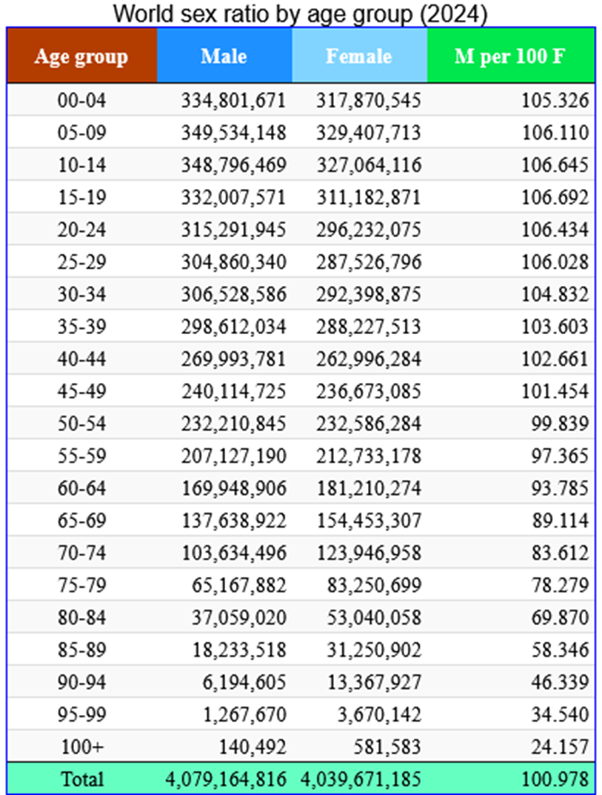

https://statisticstimes.com/demographics/world-sex-ratio.php

Remember, that 3000 souls (Acts 2:41) then 5000 men (Acts 4:4) were reported to have surrendered to the Lord prior to this complaint being made. We can see from these large increases in the Christian community that there would become administrative issues.

**Acts 6:2** **So the twelve** [12] summoned the congregation of the disciples and said,

"It is not desirable for us to **neglect the word of God**

in order to serve (diakaneo) tables.

3 "Therefore, brethren,

**select from among you** seven [7] **men**

of good reputation, full of the Spirit and of wisdom,

whom we may put in charge of this task.

Note that the disciples directed the congregation to select themselves but with four qualifications. Select from (1) men; (2) good reputation; (3) full of the Spirit; (4) wisdom.

Remember that it was Greek-Christian men who originally brought the complaint.

The issue of primary importance. . .is the distraction of the Apostles that encroached into their prayer-time, preaching and teaching God’s Word. Remember, teaching and preaching is the number one method of evangelizing Jesus gave to the Apostles. And prayer was the number one spiritual tool to prepare the Apostles to fulfill the Great Commission.

**Acts 6:4**

"But we [12 Apostles] will devote ourselves to **prayer** and to the **ministry of the word."**

5 The statement found approval with the whole congregation;

and they chose **Stephen**, a man full of faith and of the Holy Spirit,

and **Philip**, **Prochorus**, **Nicanor**, **Timon**, **Parmenas**

and **Nicolas**, a proselyte from Antioch.

Note: All seven men (by name) are from the Hellenist group.

6 And these they brought before the apostles; and after praying, they laid their hands on them.

Note: Much discussion has taken place concerning the *laying on of hands*. What do we know for sure? The ‘laying on of hands’ signified God at work in the life of the Apostles as approval was given to the seven men. They were already full of God’s Holy Spirit and possessed wisdom, faith and were of good reputation or they would not have been selected. So, those attributes were not distributed at that time to the seven men. Biblical scholars note that five times in the New Testament the ‘laying on of hands’ takes place as part of a commissioning ceremony (Acts 6:6, 13:3; 1 Tim. 4:14, 5:22; and 2 Tim. 1:6). Obviously, in a public way, symbolizing their ministry that the whole congregation could witness.

Jewish tradition dates back to the time of the Exodus when Moses laid hands on Joshua to identify him as his successor (Deuteronomy 34:9). Moses knew he was going to be taken by the Lord (die / Deut. 32:50). So, in order that the sons of Israel would listen to his successor, Joshua. . . Moses ceremoniously laid hands on him. Then the Lord came to Joshua and gave him instructions (Joshua 1:1). So, for the same reason, the public laying on hands by the Apostles upon the seven men chosen to be ministering servants. . . identified them as servants to be listened to and therefore respected as God’s servants set aside for their particular task.

**Acts 6:7** The word of God kept on spreading;

and the number of the disciples continued to increase greatly in Jerusalem,

and a great many of the priests were becoming obedient to the faith.

Once again, we have a major event take place in the life of the upcoming

“Jesus” *The Way movement* and then. . . there is numerical growth. But, this time, there is a particular note about “priests” becoming obedient to the faith. Remember, Peter’s words in his sermons were to all the Jews at the Temple which included the priest. Within these sermons and teachings, Peter continually identified Jesus as the Messiah whom the Jews had long awaited. Jesus and the disciples lived within the Second Temple period which ended in 70 A.D. with the destruction of the Temple by the Romans. During this time, the priestly Jews called the Old Testament. . . *Mikra* (Reading). The acronym "Ta-Na-K" (Law, Prophets, Writings) came into use after the Second Temple period. So, within these books, we find Isaiah 9:6-7; 53 and Jeremiah 23:5-6, along with many other Scriptures, which no-doubt got the attention of the priestly group.

**Development of the Deacon in the 1st Century**

The events in Acts 6 chronicled the appointment of the first recognized Deacons in the growing assemblies of the Gospel of Jesus. This took place soon after Pentecost, most likely no later than 34-35 A.D. We find the Deacon ministry grew and read that the Apostle Paul gave Timothy instructions regarding their qualifications. We have the letters the Apostle Paul wrote to his student, Timothy, dating no later than 67 A.D. and as early as 62 A.D. Remember, Paul is martyred in Rome before the Roman Emperor Nero died on June 9, 68 A.D. Therefore, about thirty (30) years after the Apostles give four qualifying traits for Deacons, we see Paul makes additional clarification. In review of the Acts 6 qualifications: (1) men; (2) good reputation; (3) full of the Spirit; (4) wisdom. The stunning qualification Paul adds is “women” despite his writing that “women” should not teach men (1 Timohty 2:12) and to be silent in church but to ask their husbands at home (1 Cor. 14:34-35).

**Let’s examine these verses concerning women**.

We need to note that Paul, in writing 1 Cor. 14, writes 33 verses about speaking in tongues. . . then, in verse 34, he writes that women are to be silent in church. I observe that it is not an exegetical stretch to understand that Paul is teaching that women are to be silent regarding speaking in tongues in a church service. Therefore, it is reasonable that Paul is not declaring a prohibition against women speaking (“0” zero words) in a church service. I mean, how could a woman make a verbal prayer request in church? Additionally, my review of Paul teaching that “women should be silent in church” was impacted by the very specific setting by which the congregation was surrounded. Paul did not want visitors to view the Christian women to be like the pagan priestesses.

Regarding Paul’s teaching that *women should not teach men. . .* we read in Acts 18:24-26 (Luke wrote) that Priscilla (wife) and Aquila (husband) both took Apollos (man) aside and more accurately explained the ways of God. Luke does not select Pricilla to be excluded from teaching Apollos. In three of Paul’s thirteen New Testament letters, he recognizes Priscilla and Aquila as fellow workers in Christ who risk their lives for him and thanks them on behalf of all the churches of the Gentiles (Romans 16:3) (See also 1 Cor. 16:19; 2 Tim. 4:19).

**Now, back to qualifying deacons in 1 Timothy 3:8-13**

Both men and women have basically the same qualifying traits with “fond of sordid gain” being omitted for the women. However, lest we not overlook. . .that there is no prohibition for a woman to have more than one husband. (What do you think?)

**1 Timothy 3:8-13**

8 **Deacons** likewise *must be* men of dignity, not double-tongued, or addicted to much wine or fond of sordid gain, 9 *but* holding to the mystery of the faith with a clear conscience.

10 These men must also first be tested;

Then let them serve as deacons if they are beyond reproach.

11 **Women** (**Γυναῖκας)** *must* likewise *be* dignified,

not malicious gossips, but temperate, faithful in all things.

**Γυναῖκας -**Women: primarily defined… **γυνή**, **αικός**, **ἡ** woman; (1) as distinct from a male *female, woman*

Note: Some will teach that the women here are the wives of men deacons. My review, if Paul wanted to delineate that fact, he would have said. Remember that Paul sends Phoebe as his deacon (**διάκονον).**

Romans 16:1

I commend to you our sister Phoebe, who is a servant **(διάκονον)** of the church which is at Cenchrea;

12 **Deacons** must be husbands of *only* one wife,

*and* good managers of *their* children and their own households.

13 For those who have served well as deacons

obtain for themselves a high standing

and great confidence in the faith that is in Christ Jesus.

Wow, what a lesson about women and men serving in the early Christian communities and worship services. From this, we can see that there is a high regard for biblical character traits and spiritual maturity. The moral character, spiritual maturity of a person and their family situation was considered. Why did God give these *prescriptive traits to the early church leaders?*  It is obvious that God wanted/wants His congregations to be represented by people who actually model and witness the mature relationship they have with Him and their neighbor. The meaning of the well-known statement “practice what you preach” is highlighted within these *prescriptive* directives. Make no mistake, these are not optional qualifications for deacons.

In our Fellowship here in Round Top, it is my observation that most ladies and men here qualify to be a deacon. We also recognize that we do not have elected deacons even though our local church Constitution and By-Laws allow for deacons. So, what do I see? I see that we have spiritually mature saints who simply serve where and when they can. No title sought. . . just looking for opportunities to serve, and they do. So, everyone serving in music ministry or administrative service is fulfilling the role of deacon.

Remember that deacons are ministering servants and not by definition elders. Elders have two additional qualifications that standout. . . which is the ability to teach the church (1 Timothy 3:2). And an elder must be able both to exhort in sound doctrine and to refute those who contradict. (Titus 1:9)

We close today with an observation that deacons and elders are not developed overnight. It is my opinion that the church overall is lacking in preparing men and women to serve in the community of faith.

**1 Cor. 4:16-17** 16 Therefore I exhort you, be imitators of me. 17 For this reason I have sent to you Timothy, who is my beloved and faithful child in the Lord, and he will remind you of my ways which are in Christ, just as I teach everywhere in every church.

**2 Timothy 4:1** I solemnly charge *you* in the presence of God and of Christ Jesus, who is to judge the living and the dead, and by His appearing and His kingdom:

2 preach the word; be ready in season *and* out of season; reprove, rebuke, exhort, with great patience and instruction.

3 For the time will come when they will not endure sound doctrine; but *wanting* to have their ears tickled, they will accumulate for themselves teachers in accordance to their own desires,

4 and will turn away their ears from the truth and will turn aside to myths.

5 But you, be sober in all things, endure hardship, do the work of an evangelist, fulfill your ministry.

**1 Peter 5:1** Therefore, I exhort the elders among you, as *your* fellow elder and witness of the sufferings of Christ, and a partaker also of the glory that is to be revealed,

2 shepherd the flock of God among you, exercising oversight not under compulsion, but voluntarily, according to *the will of* God;

**AMEN**

**Scripture Citation for the**

**Great Commission of Jesus Christ to the Apostles and all Disciples**

**Matthew 28:18-20**

18 And Jesus came up and spoke to them, saying,

"All authority has been given to Me in heaven and on earth. 19 "Go therefore and make disciples of all the nations, baptizing them in the name of the Father and the Son and the Holy Spirit, 20 teaching them to observe all that I commanded you; and lo, I am with you always, even to the end of the age."

**Mark 16:15** And He said to them, "Go into all the world and preach the gospel to all creation.

**Luke 24:44-49**

44 Now He said to them,

"These are My words which I spoke to you while I was still with you, that all things which are written about Me in the Law of Moses and the Prophets and the Psalms must be fulfilled."

45 Then He opened their minds to understand the Scriptures, 46 and He said to them,

"Thus it is written, that the Christ would suffer and rise again from the dead the third day, 47 and that repentance for forgiveness of sins would be proclaimed in His name to all the nations, beginning from Jerusalem. 48 "You are witnesses of these things.

49 "And behold, I am sending forth the promise of My Father upon you; but you are to stay in the city until you are clothed with power from on high."

**John 20:21-23** 21 So Jesus said to them again,

"Peace be with you; as the Father has sent Me, I also send you." 22 And when He had said this, He breathed on them and said to them, "Receive the Holy Spirit. 23 "If you forgive the sins of any, their sins have been forgiven them; if you retain the sins of any, they have been retained."

**John 20:30-31** 30 Therefore many other signs Jesus also performed in the presence of the disciples, which are not written in this book; 31 but these have been written so that you may believe that Jesus is the Christ, the Son of God; and that believing you may have life in His name.

**Acts 5:42** And every day, in the temple and from house to house, they kept right on teaching and preaching Jesus as the Christ.

**Acts 4:29-30** Your bond-servants may speak Your word with all confidence,

30 while You extend Your hand to heal, and signs and wonders take place through the name of Your holy servant Jesus."

**Acts 1:4-8** 4 Gathering them together, He commanded them not to leave Jerusalem, but to wait for what the Father had promised,

"Which," He said, "you heard of from Me; 5 for John baptized with water, but you will be baptized with the Holy Spirit not many days from now."

6 So when they had come together, they were asking Him, saying,

"Lord, is it at this time You are restoring the kingdom to Israel?"

7 He said to them,

"It is not for you to know times or epochs which the Father has fixed by His own authority; 8 but you will receive power when the Holy Spirit has come upon you; and you shall be My witnesses both in Jerusalem, and in all Judea and Samaria, and even to the remotest part of the earth."