**Round Top Church Christian Fellowship**

**Resurrection Series**

Acts of the Holy Spirit – Peter: Acts 9:32-43

Heal the Sick – Raise the Dead

November 17th, In the Year of Our Lord 2024

Pastor Matthew Diehl

(Unless otherwise noted, all Scripture is from the New American Standard Bible.)

Sermon Audio and Texts: roundtopchurch.org / Under Member’s tab

Note: The final version of the sermon is posted with possible additions.

Email questions to Pastor: [rtchurch@cvctx.com](mailto:rtchurch@cvctx.com)

In **Acts 9:1-28**, we have read Paul’s life-saving epiphany experience and his commissioning from the Resurrected Lord. Then in **Acts 9:29,** Luke gives details about how the authorities processed Paul after he gave his apologia (defense) as a person who had been arrested under theocratic charges. Last week we reviewed Paul’s witness as he gave his apologia (defense). . ."Brethren and fathers, hear my **defense (Greek: apologia)** which I now *offer* to you" **(Acts 22:1).** We see in Paul’s testimony as a defendant he presented his personal and professional life history. Paul witnesses what his life was like before and after meeting the resurrected Jesus. Paul is specific about his personal epiphany with Jesus and his surrender to the ministry call of the Lord. Paul details others who helped him "A certain Ananias, a man who was devout by the standard of the Law, and well-spoken of by all the Jews who lived there, 13 came to me, and standing near said to me, 15 'For you will be a witness for Him to all men of what you have seen and heard. 16 'Now why do you delay? Get up and be baptized, and wash away your sins, calling on His name.' It is worthy of note that in Paul’s defense (apologia) he described Ananias as a Jew who was devout in the Law and well-spoken of by all. Paul testifies that he saw Jesus again, who warned him, and also admitted he was approvingly present at the scene when Stephen was stoned to death. Paul then details his factual claim of being a Roman citizen to his Roman captors, which saved him from being beaten. Therefore, since the Roman authorities found that Paul was a Roman citizen. . . the Roman commander ordered Paul not to be beaten and turned him over to the Jewish council.

**Acts 9:29**: Therefore, those about to examine him immediately let go of him, and the commander was also afraid when he found out that he was a Roman because he had put him in chains. 30 But on the next day, wishing to know for certain why he had been accused by the Jews, he released him and ordered the chief priests and all the Council to assemble and brought Paul down and set him before them.

31 So the church throughout all Judea and Galilee and Samaria enjoyed peace, being built up; and going on in the fear of the Lord and in the comfort of the Holy Spirit, it continued to increase.

**Luke, the writer of Acts, reintroduces Peter’s Holy Spirit Great Commission Ministry. . . who heals the sick - raises the dead.**

Starting in **Acts 9:32,** we see Luke’s historical narrative focus on Peter. Remember, Peter and John were prominent Great Commission witnesses to the Jews in Jerusalem on the day of Pentecost **(Acts 2).** The day of Pentecost is celebrated by the Jews as the day Moses wrote down the Law God had given him on Mount Sinai **(Exodus 24:4-18)** and the celebration of the wheat harvest. Pentecost is fifty days after Passover. Remember, Jesus was crucified during Passover week. Peter and John continued their witnessing mission in Jerusalem and were the first to be arrested for their testimony in Jesus’ name **(Acts 4).** Luke reintroduces Peter’s activities in **Act 9:32.**

32 Now as Peter was traveling through all *those regions*,

he came down also to the saints who lived at Lydda.

33 There he found a man named Aeneas,

who had been **bedridden eight years**, for he was paralyzed.

34 Peter said to him,

"Aeneas, **Jesus Christ** heals you; get up and make your bed."

Immediately he got up.

35 And all who lived at Lydda and Sharon saw him,

and they turned to the Lord.

36 Now in Joppa

there was a disciple named Tabitha (which translated *in Greek* is called Dorcas);

this woman was abounding with deeds of kindness and charity which she continually did. 37 And it happened at that time that **she fell sick and died**; and when they had washed her body, they laid it in an upper room.

38 Since Lydda was near Joppa, the disciples,

having heard that Peter was there, sent two men to him, imploring him,

"Do not delay in coming to us."

39 So Peter arose and went with them.

When he arrived, they brought him into the upper room;

and all the widows stood beside him,

weeping and showing all the tunics and garments that Dorcas used to make while she was with them.

40 But Peter sent them all out and **knelt down and prayed,**

and turning to the body, he said,

**"Tabitha, arise."**

And she opened her eyes,

and when she saw Peter, she sat up.

41 And he gave her his hand and raised her up;

and calling the saints and widows, he presented her alive.

42 It became known all over Joppa,

**and many believed in the Lord.**

43 And Peter stayed many days in Joppa with a tanner *named* Simon.

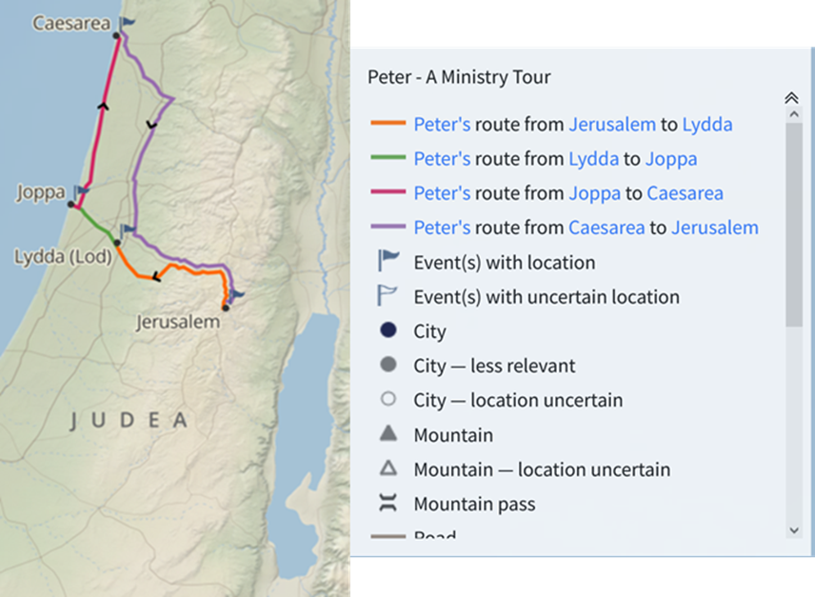

Wow, what a story. . . I mean, we have miraculous things happening. Were there miraculous ministry events predicted to take place. . .as they say. . . “who would have known?” So, who does all this work? My observation is that “The” God who created the heavens and the earth (all that is), who designed and fine-tuned the universe, all living biology and assembled the *elements* we list in the *periodic table of elements* to sustain life. . . is the “One” and only God of life-miracles.

So, what do we know about life. . . I point to the familiar elements in the periodic table that are arranged in the right microscopic amounts and order with a value to create and sustain life. Who did this ordering and timing? The reality is that the more investigation scientists pursue, the more complex life becomes, and there is a general acceptance by the scientific community that no random process could create or sustain life. All that is, had to be designed and fine-tuned for life to be and be sustained.

**In chemistry, a periodic table is** the organized array of all the chemical elements in order of increasing atomic number—i.e., the total number of protons in the atomic nucleus. When the chemical elements are thus arranged, there is a recurring pattern called the “periodic law” in their properties, in which elements in the same column (group) have similar properties. The initial discovery, which was made by Dmitry I. Mendeleev in the mid-19th century, has been of inestimable value in the development of chemistry.

https://www.britannica.com/science/periodic-table

So, in layman’s terms, what did Jesus tell the disciples concerning their future ministry and what/how they would be witnessing and accomplishing in His name? Did Jesus tell them to mix some chemicals together. . . heating them or cooling them to the right temperature to ingest? No. How do you chemically make love, joy, grace, forgiveness, gentleness, kindness, patience, and the knowledge of Gospel Message. . . the Good News of the Cross of Christ? You do not make these things - God does. I observe that God created the chemistry for life but His temporal chemistry (human beings) has to be Holy Spirit directed to produce His witness of eternal life to be shared with others. In his letter to Believers, John records Jesus’ instructions on how all of this works.

I encourage all to use this passage of Scripture to detail how God works in the lives of Believers accurately**.** Belief is not only agreeing with God (James 2:19) but a total heart-surrender. . .to loving trust with your heart, soul, might, and mind (Deut. 6:5, Matthew 22:37). The ***human soul*** is what God gave people over the capabilities of animals to be hardwired to Him. And therefore, have the ability to be directed by His Holy Spirit. Paul writes to Believers in Galatian. . . "I have been crucified with Christ; and it is no longer I who live, but Christ lives in me; and the life which I now live in the flesh I live by faith in the Son of God, who loved me and gave Himself up for me. (Galatians 2:20)

**John 14:12-31**

12 "Truly, truly, I say to you, **he who believes** in Me,

the works that I do, he will do also;

and greater *works* than these he will do;

because I go to the Father.

13 "Whatever you ask in My name, that will I do, [Qualifying verse] 1 John 5:14 This is the confidence which we have before Him, that, if we ask anything according to His will, He hears us.

So that **the Father may be** **glorified** in the Son.

14 "If you ask Me anything in My name, I will do *it*.

15 "If you love Me, you will **keep My commandments.**

16 "I will ask the Father,

and He will give you another Helper,

that He may **be with you forever;**

17 *that is* the **Spirit of truth,**

whom the world cannot receive,

because it does not **see** Him or **know** Him,

*but* you know Him because He abides with you and will be in you.

18 "I will not leave you as orphans;

I will come to you.

19 "After a little while the world will no longer see Me,

but you *will* see Me; **because I live, you will live also.**

20 "In that day you will know that I am in My Father,

**and you in Me, and I in you.**

**21 "He who has My commandments and keeps them is the one who loves Me;**

and he who loves Me will be loved by My Father,

and I will love him and will disclose Myself to him."

22 Judas (not Iscariot) said to Him,

"Lord, what then has happened

that You are going to **disclose Yourself to us and not to the world?"**

23 Jesus answered and said to him,

**"If anyone loves Me, he will keep My word;**

and My Father will love him,

and We will come to him and make Our abode with him.

**24 "He who does not love Me**

**does not keep My words;**

and the word which you hear is not Mine,

but the Father's who sent Me.

25 "These things I have spoken to you while abiding **with** you.

26 "But the Helper, the Holy Spirit,

whom the Father will send in My name,

He will teach you all things,

and bring to your remembrance all that I said to you.

27 "Peace I leave with you; [Prince of Peace (Isaiah 9:6)

My peace I give to you;

not as the world gives do I give to you.

Do not let your heart be troubled, nor let it be fearful.

28 "You heard that I said to you,

'I go away, and I will come to you.'

If you loved Me,

you would have rejoiced because I go to the Father,

for the Father is greater than I.

29 "Now I have told you before it happens,

so that when it happens, you may believe.

30 "I will not speak much more with you,

for the ruler of the world is coming,

**and he has nothing in Me;**

**[Believers are not to have Satan in them]**

**31 but so that the world may know that I love the Father,**

**I do exactly as the Father commanded Me.**

**Get up, let us go from here.**

**AMEN**